ADSelfService Plus

The new service for password management for @uniupo accounts comes with a website and a smartphone application.
There are a few steps to complete during the registration of your account in order to ensure a high level of security for your account
The registration can be done either on the official uniupo website or directly onto the ManageEngine ADSelfService Plus app.
The account is unique to Ateneo and it grants access to its email, single-sign-in web services, workstations and so on…
If you are a student, you can enter your serial number. In case you haven’t yet completed enrolment procedure or you are a company, the authentication process can be completed by putting the username you chose during the account registration at www.studenti.uniupo.it. In both scenarios, you’ll need to select the “Studenti/esterni” domain.
If you are part of the staff, whether you are a professor/researcher/TAB, you need to select the domain of your account, for example “Rettorato” or “POLOVOC” and then insert your username.
Remember to put “@” after the username.

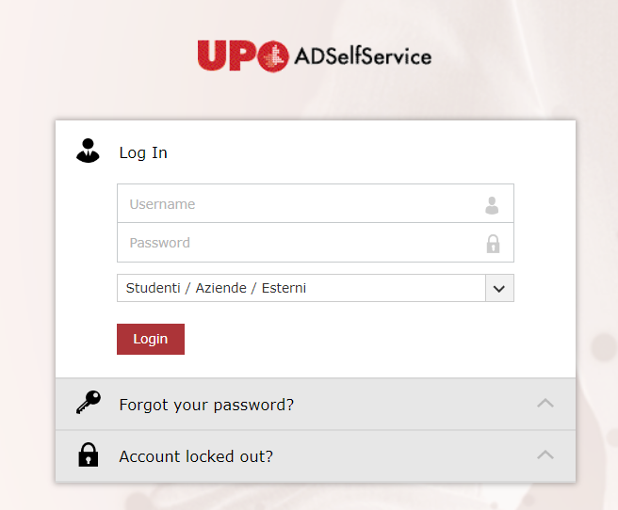

When the authentication process is completed, it will take you to a page where you’ll be able to change your password .
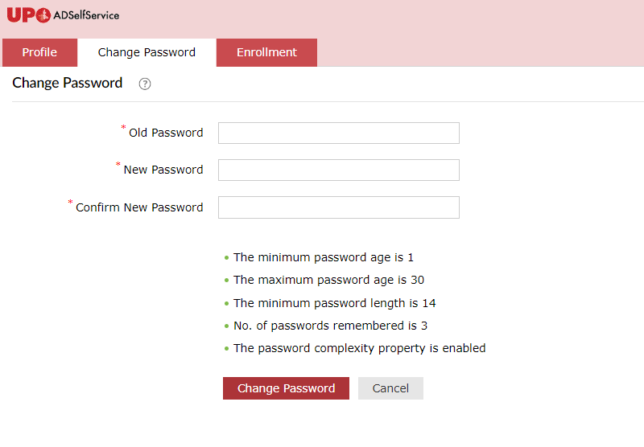
In order to activate all the functions, you need to click on “Enrolment”
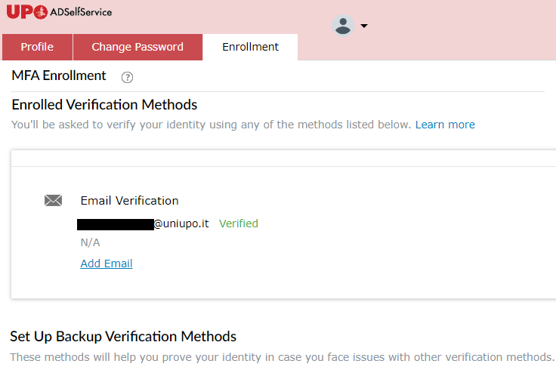
On this screen we can see at the top that the email used for the verification method is already set up.

You can also add another e-mail address just in case the institutional e-mail address isn’t available:
- Click on “Add e-mail”
- Insert your chosen e-mail address and validate it by typing the code sent on that e-mail address
On the lower end of the screen there’s the option to activate other MFA authentication methods such as: security questions and, after using the app at least once, using your digital fingerprint or the OTP codes.

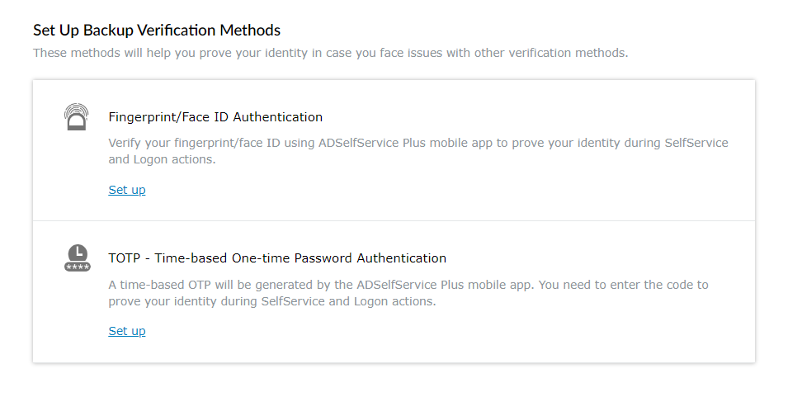
Every method can be activated separately.

Examples of MFA activation

In order to use the app you’ll need to set it up first. We can proceed through a guided method with a QR Code by selecting the “Mobile Access” option up on the right. It will open a window with instructions on how to connect the app to the UPO server.

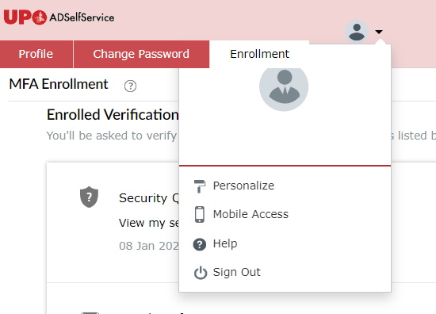

If you prefer to set it up manually, you’ll need to set up 3 parameters; on the home screen click ‘’Server Settings’’ > insert the following configuration:
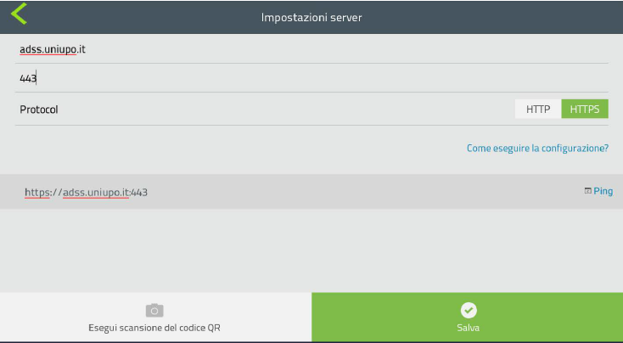

After the confirmation you will be able to log-in both on the website and on the app.
At this point, you will be able to proceed with changing your password.
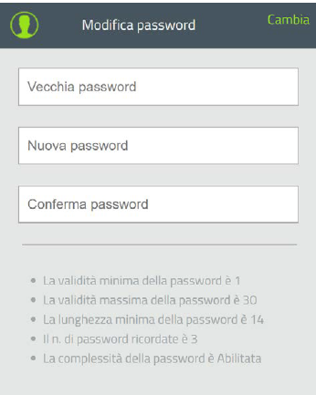

Or by clicking the profile icon, going to the menu screen and going on the “Enrolment” option, where you’ll find the security questions etc..
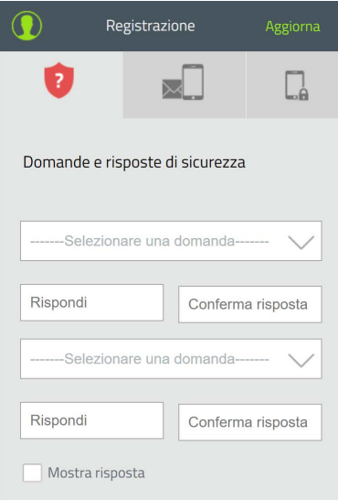

Click “Apply” to save the settings.

